Project 4 Good Eats

CIS 436 – Summer 2017

Developer:

**Objective**

* To solve the worldwide problem “What should I eat today?”

**Usage**

* To provide users the random options of food so they do not have to have a headache with deciding
* To track and store user preferences for cuisines
* Allows users to search for different cuisines with custom filters
* Helps users to figure out recipes for food

**Developing**

* Java with Android Studio
* SQLite DB

**Functionality**

* **Main Activity and Fragment**
  + Button control the random food Picture showing up
  + Favorite icon for checking if the food is favoured and store the data

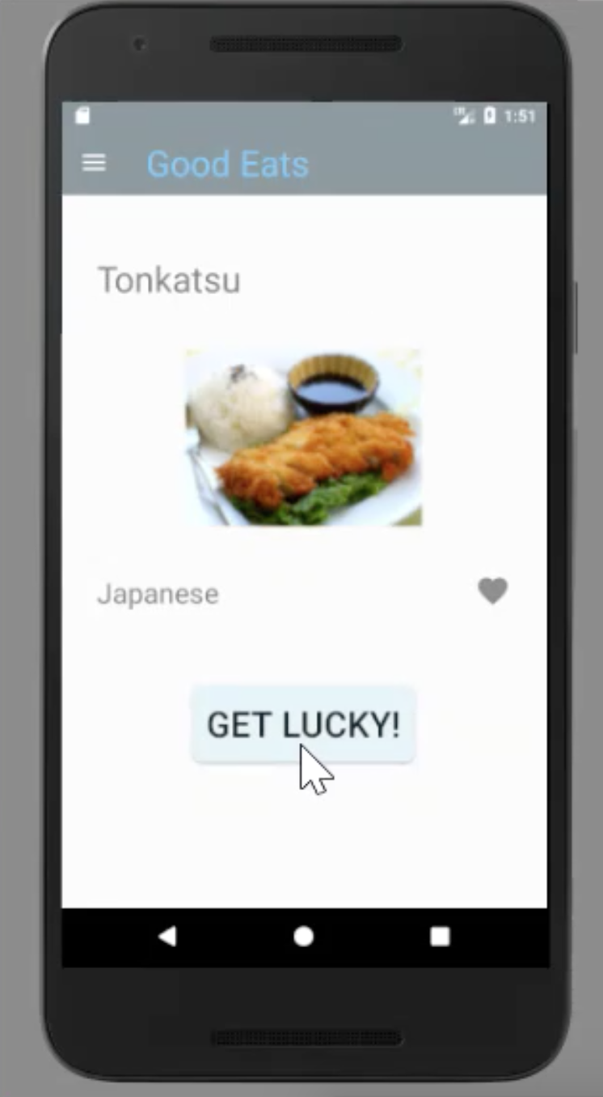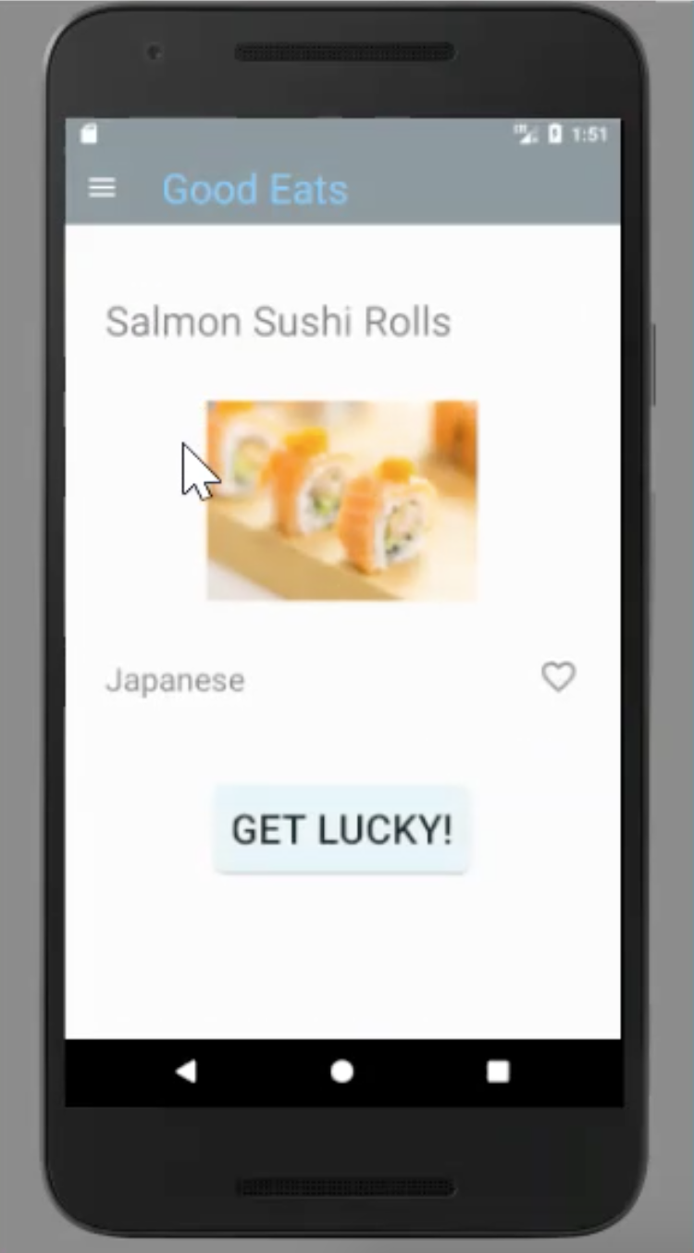

* **Search Activity and Fragment**
  + Allows users to search for different cuisines
  + Chips in the search fragment (custom filter)

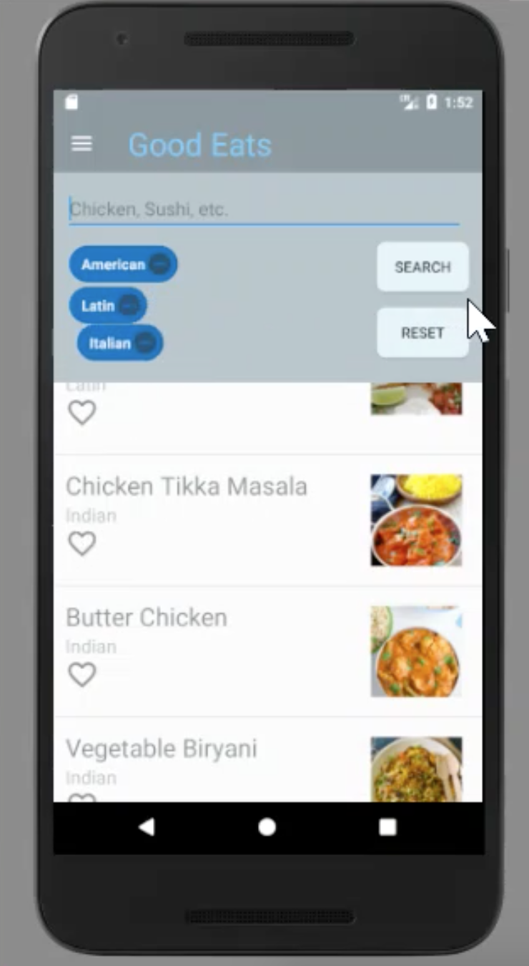

* Favourite Activity and favourite list fragment
  + Track when the food is favoured and store the data in DB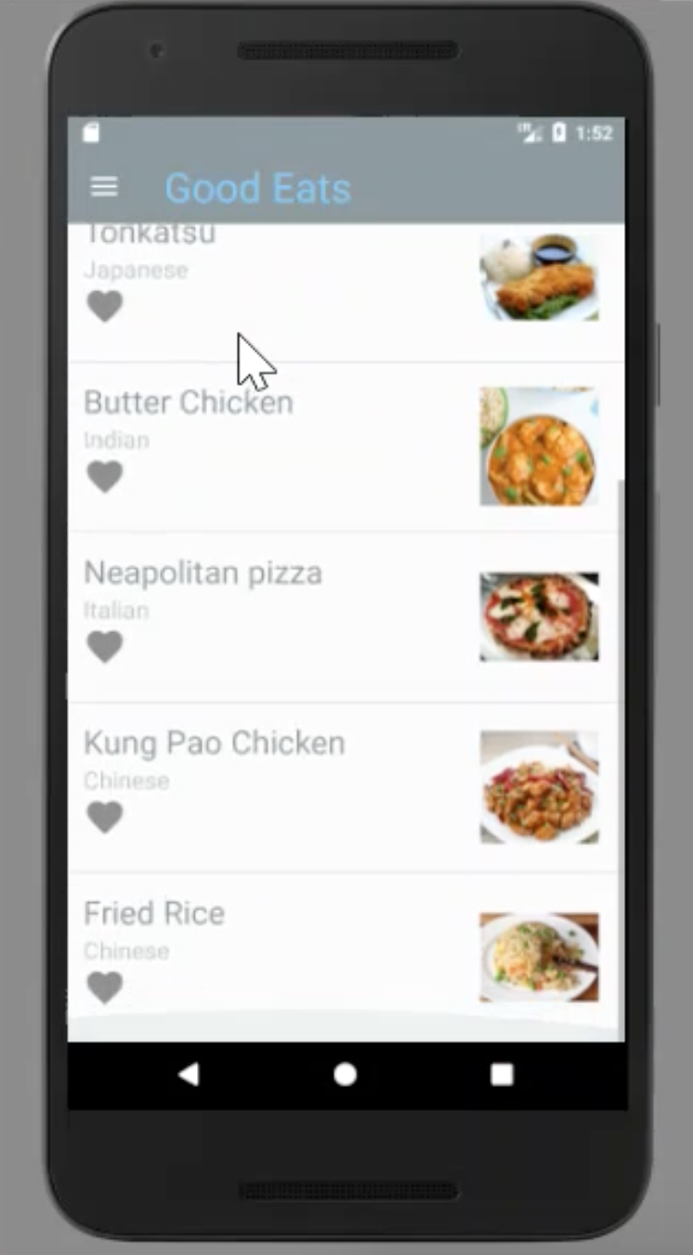
* Menu drawer
  + 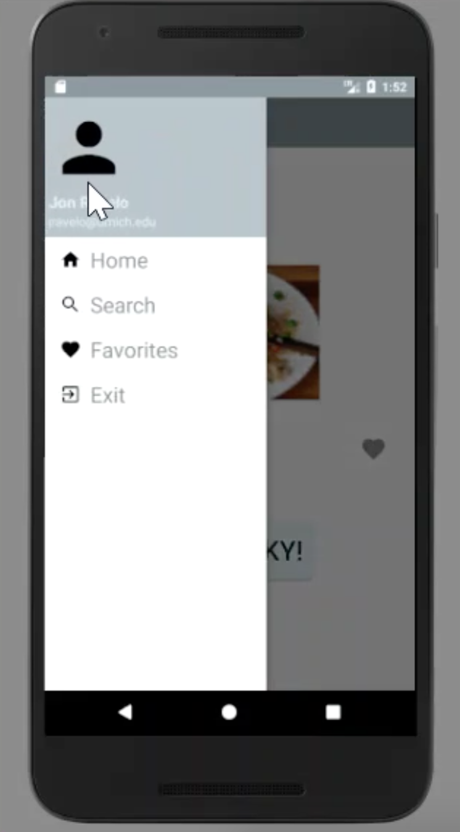Navigate to each functionality of the app